## Align Logos



## 

## Align Colors

Warm/pastel colors

| #9F5255 Main Color |
| --- |
| #E16A54 Secondary Color |

Other accent colors:

<https://colorhunt.co/palette/8174a0a888b5efb6c8ffd2a0> <https://colorhunt.co/palette/deaa79ffe6a9b1c29e659287>

 These colors are used for the calendar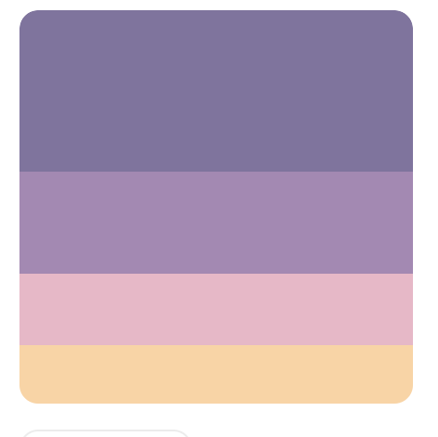

## Align Fonts

Sans serif

1. Spectral
2. Courier Prime
3. Alumni Sans
4. Patrick Hand
5. Public Sans

**Personality**

We are cheerful champions for truth. We’re factual. We’re positive. We’re outspoken. We always lead with empathy, and we’re often disarmingly honest. In school, we were the quiet one who always asked the question nobody else thought of. At work, we’re the one to speak up and say “No, this is wrong, and we’re going to take the time to do it right.”

* We’re honest, and sometimes inconveniently so, but we’re never tone deaf.
* We know when to speak and when to listen.
* We never exaggerate. Reality is plenty weird on its own.
* We’re tireless with high standards. (We are software, after all.)
* We’re empathetic to the pressures people feel at work.
* We’re curious about everything, and are constantly verifying things on our phone.
* We love fun facts.
* We’re neat.

## **Voice**

When we write and we speak, we want others to feel like they’ve been heard. Like what they say matters, and that we’ve taken them seriously. When others speak, we furrow our brow and listen. We want anyone to feel comfortable bringing their problems to us, and confident that we’d never pass judgment — because we wouldn’t. We choose our words deliberately and would never be caught shouting … unless it was to let someone know they dropped their wallet.

Keep it simple. We always prefer a short sentence over a long, stuffy one. Same with words

Front-load the meaning. To be ultra clear, we begin paragraphs with the most important thing. For example, rather than Slack someone with a long story that ends with a request, we’ll start with the request — “Do you have 30 minutes to help?” — and work back.

Check your facts. We take great pride in knowing the truth and citing our sources.

Always edit. Never submit something unless you’ve read through it yourself.

Avoid adverbs. Those are words that modify other words, like “very,” “super,” “basically,” etc, as there’s probably a stronger word.

Leave room for doubt. We like to say “often” or “sometimes” because absolutes like “always” or “never” are rarely true.

Eliminate jargon. Avoid using industry-specific words that others won’t easily understand.

Fight statistical exaggeration. Statistics have a way of growing more extreme the more they’re shared. Keep yours honest, even if it means they require more explanation.

Reframe negative statements to be positive. For example, turn “no shipping fee” into “free shipping.” It’s shorter, more accurate, and more upbeat.

Check your homonyms and homophones. These are words that are pronounced the same but spelled differently. E.g. “they’re” and “their.”

When in doubt, delete “that”. “That” tends to get overused. If you can delete it and a sentence reads the same, please do.

Double-check all pronouns. If it’s not clear what your “it” or “that” is referring to, bring the noun up again.

Be specific. Is it a river or is it the Nile? Is it a truck or is it an eighteen-wheeler? Specificity paints the picture.

Hyphenate modifiers. Radio was invented in the 19th century; your grandfather collects 19th-century radio sets.

Limit exclamation points. One per article is plenty.

Check adjectives. Are they all necessary? Would a more specific noun choice be better? Is it a big house or a mansion? A brimmed hat or a fedora?

Trim your lists. If you’ve listed three things that are synonyms, pick the best and delete the rest.

Kill your darlings. Don’t keep something because you like it; keep it because it works.

Use diverse examples. If inventing names, mix them up. Don’t just stick to Anglo-Saxon Jacks and Jills. Same with genders and ages.

## **Tone**

While we’ll only ever have one voice (it’s who we are), sometimes, we’ll alter our tone to match the situation. *(Like whispering in a crowded theater.)* Sometimes, we’ll adopt pieces of the language of those we’re speaking to. For example, we know that people who attend school are students, not consumers.

When discussing why we chose the colors that our website uses, explain the reasoning for why we chose them. The colors were chosen as they are gender neutral and exclude a welcoming feeling to the users.

In sales outreach, begin with the specific reason you’re reaching out. If it’s difficult to be specific, it’s a sign you need to conduct more research.

In discussions, it’s okay to repeat yourself. People are accustomed to boring discussions and tend to tune out. You can help them by intentionally reiterating your main point.

In legal documents, stick to our voice and avoid legalese. Even if it’s accurate, it’s not accessible. We prefer our truths to be clear and everything cited.

## **Things to avoid**

### **Things our legal team says not to do**

* Do not use Align in possessive form. E.g. “Align’s agreement.”
* Do not use Align in plural form. E.g. “The customers talked about their Aligns.”

### **Words and phrases to avoid**

Harmful, toxic, or questionable language such as blacklist, swarthy, or dame.

Gendered terms such as “Hey you guys” or “man hours.”

Alienating words or phrases especially those that apply to marginalized groups. E.g. “Driving *blind*.”

Figures of speech that refer to war or violence, like “spray and pray” or “tools in your arsenal.”